Support the Isosaki’s on their Mission Trip to Japan!
We are excited to have the opportunity to visit the people and churches of Shingu, Tamagawa, Niiza, and Machida, and to serve with our God-given abilities for the fourth year. We are traveling as a team of six this year; giving us more opportunities to reach the Japanese people. We have seen first hand that God is truly moving among the Japanese people. As a result of their previous trips, people have begun to participate in Bible studies, bringing their children to church, and 17 people have made their first-time decision to follow Jesus Christ! We will be traveling to Japan for two weeks in late July and early August.

What will we be doing in Japan?

While we are in Japan, we’ll reach out to the youth, and expose them to the good news of Jesus Christ. We will be leading English Cafés for children and adults, assisting in worship and Bible studies, and directing multiple Vacation Bible Camps as well as cooking classes. We are excited to inspire and equip church leaders by creating sustainable ministries that have an eternal impact.

How can you support us on our mission to bring Jesus to Japan?

For this missions trip to become a true reality, we will need both prayer and financial support. It is our goal to raise $6,500 total for travel and food expenses. We are asking you to seek the Lord for His guidance on giving to support our trip.There are 127 million Japanese that do not know Christ. Your support for this trip helps equip our team with the readiness that comes from the gospel of peace.
If you find yourself being called to support us through prayer or finances and would like to know more about our trip, or you are just interested in following us on our trip, you can check out our blog: https://missionsinjapan.weebly.com/ It contains a wealth of information on what our trip will look like, and the impact previous missions trips have had. You will also find information on how to join our prayer support team and our financial team.

Thank you for being willing to read this letter and consider supporting our trip prayerfully or financially. We sincerely appreciate the relationship we have with you and we hope to hear from you soon! If you have any questions or concerns feel free to contact one of us.

Meet Our Team

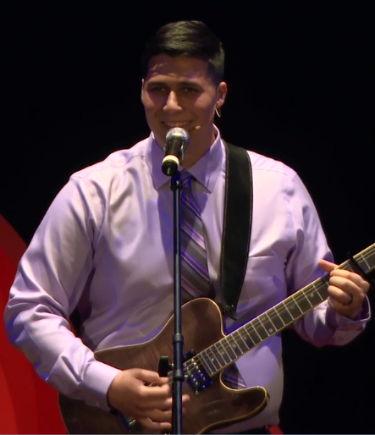
Joe Isosaki Felicia & Hezekiah Isosaki Preston Winowiski Lily King Brandon Dasher

